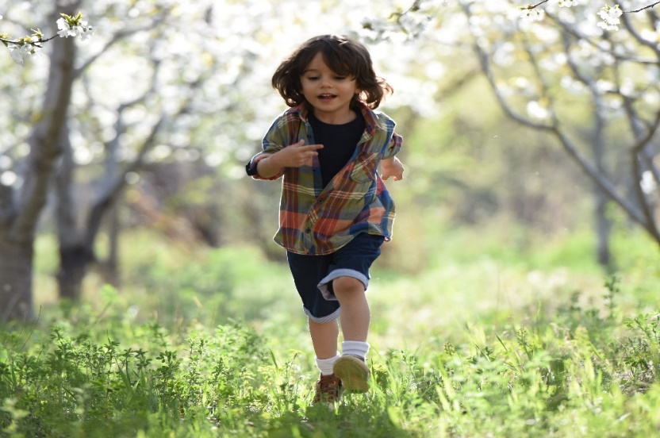

Ms. Jane Doe
Your Local Department Store
111 Any Street
Suite A
Anytown, FL 00000

Dear Ms. Doe,

Did you know one in four Anytown families can’t afford to buy their children properly fitting shoes?

Ill-fitting shoes can lead to bone and muscle deformities in kids’ feet. A pair of shoes that fit properly is the easiest way to prevent deformity and injury in children’s feet and legs. Anytown Orthopedic Association is working to give all families access to properly-sized children’s shoes.

Anytown Orthopedic Association was established in 1998 to address the growing need for orthopedic medicine in Any County. We want to provide shoes to every local family in need using funds from our first annual Step Up for Kids fundraising event. The fundraiser takes place at The Anytown Rec Center on March 1st from 4:00 p.m. to 8:30 p.m. and will feature dinner, dancing, and a silent auction.

As one of the most popular stores in Anytown, we would appreciate your help making our fundraiser a success. Your donation of a gift basket or gift card will make a huge difference in the lives of local children who need shoes that fit properly. In exchange for your support, Anytown Orthopedic Association will recognize Your Local Department Store’s tax-deductible gift both online and at our event.

We’ll recognize Your Local Department Store in the following ways:
- Two free tickets to Step Up for Kids
- A Thank You in the event program
- Your Store Logo displayed at the auction table
- A public thank you message on social media
- Your logo added on the “Supporters” page of the event website

Thank you for your consideration of our request for a donation item for our Step Up For Kids event. For more details about the event, and how you can help, contact me at (800) 555-5555 or john.johnson@anytownortho.org. I hope to hear from you soon!

Sincerely,

John Johnson
Director of Philanthropy
Anytown Orthopedic Association

P.S. Anytown’s kids need you to step up for them. Please help us prevent painful feet deformities by donation children’s shoes for our event!

